**Building Your Paper Part I**

Space is crazy place, home to some of the most outlandish phenomenon and objects that the human mind can conceive of. What, though, could the *most* outlandish phenomenon and inexplicable celestial body *be*? While there are many candidates, one that stands out above many, many others, is the magnetar. Not only are magnetars the compressed aftermath of gigantic stars, but they also boast the most intense magnetic fields known to the universe and showcase the curious depth of relation between electricity and magnetism. And just what makes them tick?

In order to understand magnetars, one has to understand neutron stars. For a star larger than our sun, but smaller than capable of creating a black hole, when it dies, the star will collapse in on itself and the outer layers will reverberate off the inner, increasingly compressed layers, and bounce off, creating a supernova. Provided the star is large enough, that compression in the middle is where things get interesting. The atoms are pushed together so hard that the protons and electrons literally fuse together, leaving behind an incredibly dense mass, a neutron star. After taking such a large object and compressing it, thanks to the conservation of angular momentum, the newly formed object spins. Very. Very. Fast. Similarly, the previous star’s magnetic field is amplified, and if it is spinning fast enough, a so-called ‘dynamo effect’ will amplify the field yet again, resulting in a magnetar.

Currently, there are many questions and possible answers regarding magnetar mechanics, but many are hard to prove based on our limited exposure to their data. For example, there are only around 10 known magnetars from which to collect this data, but there are many pulsars we *can* take data from that are fairly similar. Our current information comes largely from theory and radiation readings from satellites and probes. For example, we can measure the period of a distant magnetar by reading the time in between radiation signals we receive, and can thus measure the strength of their magnetic field using:

Bd=3.2×1019√PṖ G

With extremely fast rotation periods, we see magnetic fields between 1014 -1015 G. Fields of this strength are capable of polarizing the vacuum around them. A hydrogen atom, under these conditions, will be stretched 200 times narrower and into a long cylinder thinner than the quantum-relativistic wavelength of an electron. Right now, one of the theories regarding these gargantuan fields simply comes down to conservation of angular momentum: the strong magnetic fields are simply remnants of the most magnetically active stars, amplified by the 1.5 million-fold compression of the star. The leading theory, however, expands upon this by describing why there is a multi-order of magnitude difference in the magnetic fields between pulsars and magnetars. This model agrees with the previous, but additionally comments on how ionized fluids within the newly born neutron star can cause a dynamo effect and further amplify these fields.

In fact, both the earth and our own Sun have magnetic fields because experience they also dynamo action, just to a much lesser extent. One way to visualize this phenomenon is by looking at a current computational model. In this technique, the dense fluid of neutrons inside a neutron star (before becoming a magnetar) resemble convection in a pan of boiling water – hot patches of fluid rise and cool ones fall. As this hot, dense fluid is circulating, the free electrons and protons in the fluid get caught up and carried by these currents. Flowing electrons are current, and these currents can sweep by and pick up any of the magnetic fields that are already inside of the neutron star. Normally, this ionic fluid flows in varying directions and strengths in different parts of the star and can cancel each other out or slow other currents down. The dynamo theory states that pulsars are stop here; their magnetic field amplified from compression and whatever currents inside are sporadic and non-uniform. If a star was already rotating faster than normal, however, once compressed to a neutron star in the early stages of its life, it could spin so fast that ionic currents inside the star align and become far more uniform. This uniformity of spinning electric fields serves to amplify the magnetic fields even more, turning them into the strongest in the universe.

In a more concrete sense, in nature, we find that the Rossby number (Ro) of a neutron star determines the strength of its dynamo action. Where P is the period of a spinning neutron star and Pc is the period of convection inside the star, Ro = P/Pc. Where Ro >> 1, there will be little or no dynamo, Ro ~ 1, there may be some dynamo action typical to a pulsar, and where magnetars are concerned, Ro ≤ 1. The reason that the Rossby number of a neutron star is so indicative of its magnetic field strength is rooted in the Law of Inductance/Dynamo Equation

= λ∇2**B** + **∇** x (**u** x **B**). (1)

The two different terms can be broken down into and entropy gradient and a lepton gradient: as entropy and/or the flow of leptons (electrons) within the neutron star increase, so too does the magnetic field. What’s more, knowing ξ ≡| Bt/Bp|, where Bt is the toroidal component of the magnetic field and Bp is the poloidal component of the magnetic field (shown below), we can use the poloidal magnetic field equation

Bps ≈ Beq(1 + ξ)−1 $\sqrt{Pc/P-1}$ G. (2)

where Beq depends on the physical speed, size, and density of the neutron star.

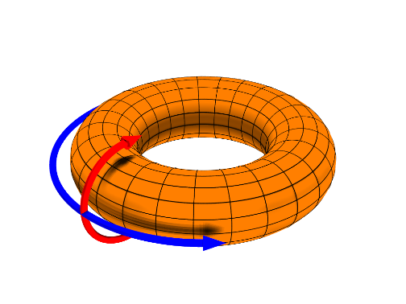

The blue arrow represents poloidal motion, while the red arrow represents toroidal motion

We can use this equation because, for a low enough Ro, we can treat the magnetar almost as a rigid rotator and only pay attention to it’s rotational (poloidal) components. Continuing, if the period of rotation is small enough (P < Pc[1 + (1 + ξ)2]−1), then the dynamo leads to a very strong magnetic: Bps > Beq ∼ 3×1013 G. That, however, is pulsar-level magnetization. In order to achieve our sought after field, the period must be even shorter, less than ~0.1Pc. When this *is* the case, from Eq. (2), we find that

Bps ∼ 0.3Beq ∼ 1013 G. (3)

The smallest period for a neutron star is around 1 millisecond, allowing the dynamo to produce a field ∼3 × 1014 G. If a field is any stronger (we mentioned that they can breach up to 105 G), then the dynamo will be used in addition to the already present and amplified rotation from when the star was compressed. Do note that all the dynamo action occurs within the first 30-40 seconds of a newly formed neutron star’s life. That is the leading theory as to how magnetars are bestowed with the mighty power of the strongest magnetic fields in the universe.